Swiss Netball League
Team Registration & Final Score Sheet
Match Date:
Match: | Home Team: | v | Away Team:
Final Score: |  | Match won by:
Player’s Player: | Home Player: |  | Away Player:

Home team name: |  |  | Away team name:
1 |  | Captain | 1 |  | Captain
2 |  |  | 2
3 |  |  | 3
4 |  |  | 4
5 |  |  | 5
6 |  |  | 6
7 |  |  | 7
8 |  |  | 8
9 |  |  | 9
10 |  |  | 10
11 |  |  | 11
12 |  |  | 12

Printed name of match officials | Signatures
Umpire 1: |  |  | Qualification:
Umpire 2: |  |  | Qualification:
Scorer Home Team:
Scorer Away Team:
Time keeper:
The HOME Team must send this final score sheet to operations@swissnetball.ch within 24 hours of the match.
Both teams must text the final score to +41.79.772.9578 within 2 hours of the end of the match.
Both Teams should take and retain a photo of this final score sheet for possible future reference.

Swiss Netball
League Match Score Sheet
Match Date: |  | League: | Matterhorn / Monte Rosa  Delete as appropriate
Venue:
Home Team: |  | Away Team:
IMPORTANT:
- Both Scorers (one from each team) and one Timekeeper must sit together close to the court
- The two scorers should agree the scores at the end of each quarter
- REMEMBER time ends on the Umpire’s whistle and NOT when the Timekeeper calls ‘Time’

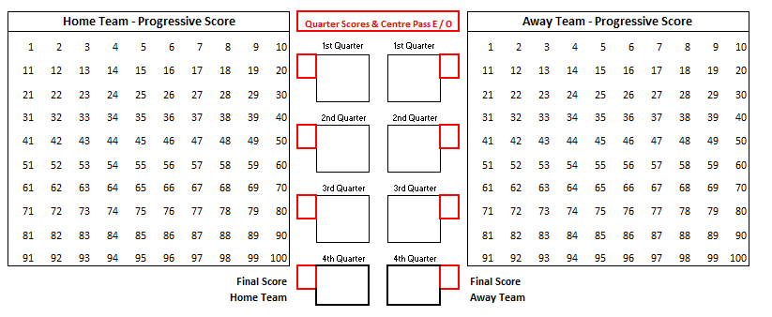
Suspensions / Ordered Off
Home Team |  | Suspension or  Ordered Off | Away Team |  | Suspension or  Ordered Off
Player Position | Time |  | Player Position | Time

How to score Odds and Evens game
Once the 'coin toss' has been taken by the team captains before the game begins and the team taking the first Centre Pass has been decided:
1) Enter 'E' for EVENS in the 1st Quarter Centre Pass box to the team who is taking the first centre pass
2) Enter 'O' for ODDS in the 1st Quarter Centre Pass box to the opposing team
Once play begins, strike out the existing number after a team scores a goal. At the end of each quarter circle the current score and enter into the relevant quarter box.
To calculate which team should take the next centre pass, add the scores together eg. 5 + 9 = 14 which is an even number so the next centre pass would go to the ‘EVENS’ team.
Enter an ‘E’ or ’O’ for the appropriate team with the first centre pass at the start of each of the 2nd, 3rd and 4th quarters (leaving the opposing team box blank). Visually check with the umpires to confirm the correct centre pass is indicated / being taken at the beginning of each quarter.

