Club XY
Rue des Exemples x
CH-XXXX Lieu Exemple

T +41 XX XXX XX XX
info@clubxy.ch
www.clubxy.ch

« Club XY »
Protection concept for training from June 6, 2020

Version : 31 May 2020

Author : First and last name of the person responsible for the coronavirus plan

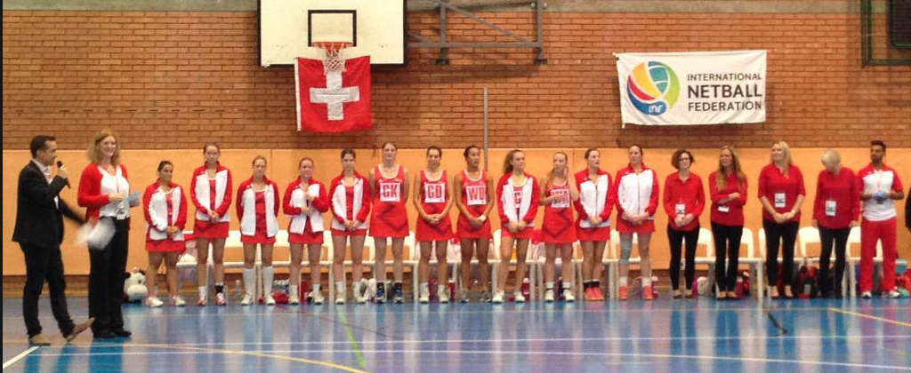
Text of photo of your club
New framework conditions
As of June 6, 2020, training is once again authorized in all sports, subject to compliance with the protection concepts specific to each club. For sports activities requiring close and constant physical contact, training must be organized in such a way that it takes place exclusively in fixed groups and with an attendance list. This concerns especially periods of close contact when people stay for a long time (more than 15 minutes), or repeatedly, at a distance of less than two meters from each other, without protective measures.

The following five principles must be observed during training:

No symptoms during training

People with symptoms of illness are NOT allowed to attend or participate in training sessions or competitions. They must stay at home, self-isolate and contact their doctor.

Keep your distances

On the outward journey, on arrival at the sports facility, in the changing rooms, during discussions, when showering, after training and during the return journey - in these or similar situations, you must keep your distance from other people. “High Fives” and handshakes are still not permitted. Body contact is only allowed again in all sports during training itself. Training must take place in a space of at least 10 m2 per person, which means that a maximum of XY people can participate in our training.

- Wash your hands thoroughly

Hand washing plays a key role in hygiene. It is therefore important to wash your hands with soap, before and after training, to protect yourself and those around you.

Establish attendance lists

Upon request, close contacts from the past 14 days must be able to be reported to the health authorities. In order to simplify the tracking of people, the club must maintain attendance lists for all training sessions. The person in charge of each training session is responsible for keeping a complete and exact list of people present as well as forwarding it to the person responsible for the coronavirus plan (see point 5). The club is free to decide the format in which it wishes to keep these lists (for example: doodle, application, Excel, etc.).

Designate a responsible person within the club

Every organisation planning to resume training must appoint a person responsible for the coronavirus plan. This person is responsible for ensuring that all regulations are observed. In our club, it is First name Last name. If you have any questions, please contact her/him directly (Tel. +41 79 XXX XX XX XX or firstname.lastname@clubxy.ch).

6. Specific requirements
Description of specific measures linked to the place or other circumstances

Zug, XX XXX 2020 Signed Committee Club XY

